Bash script -02
Create a bash script to check if a directory is available or not
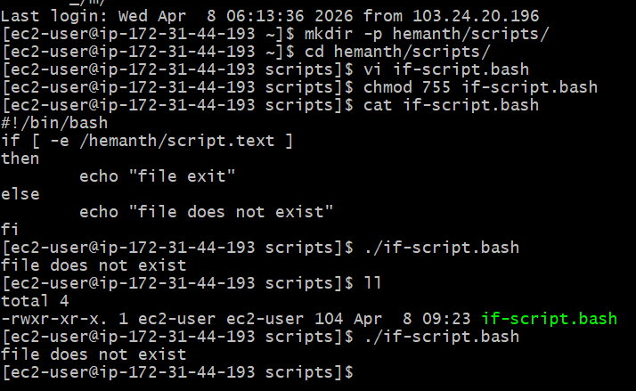
Create a bash script to create multiple files…
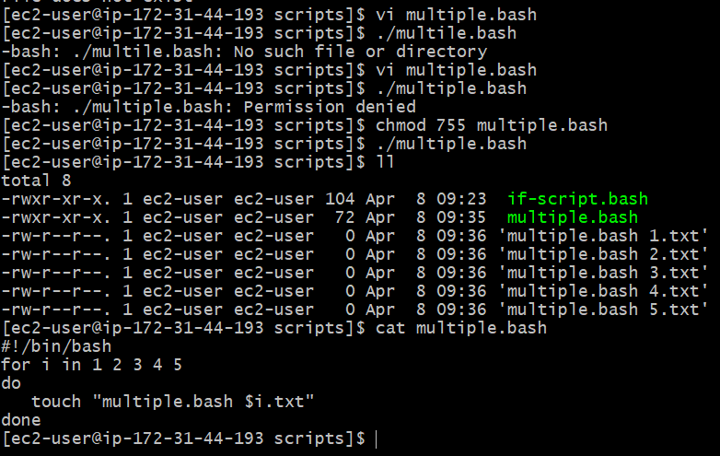
Create a bash script to install Nginx on an ec2 server…
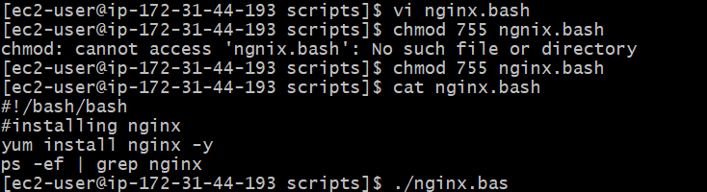
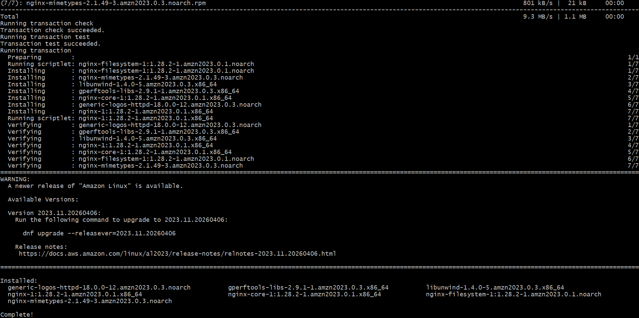
Create a bash script to check the nginx service is running. if not running then script should start the service ..
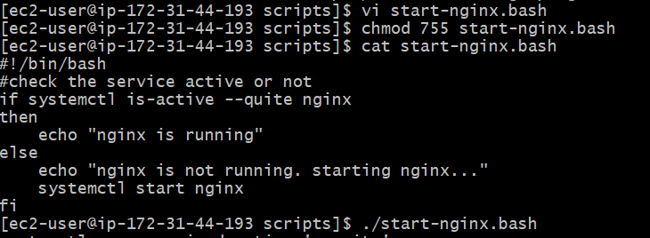
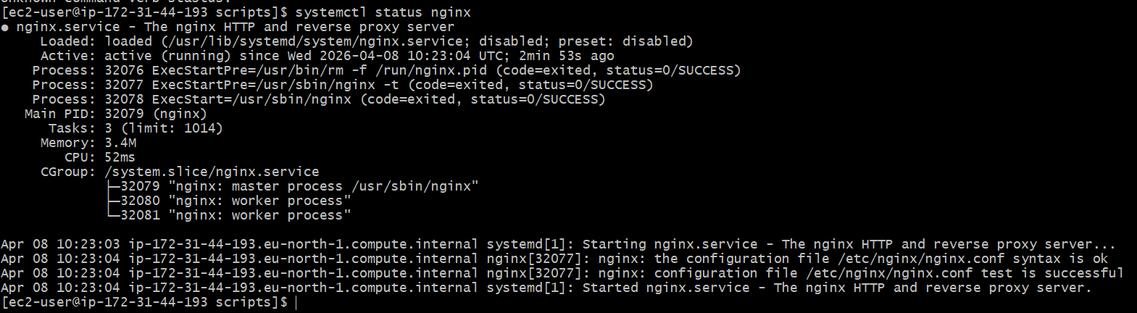

Create a bash script for a calculator.
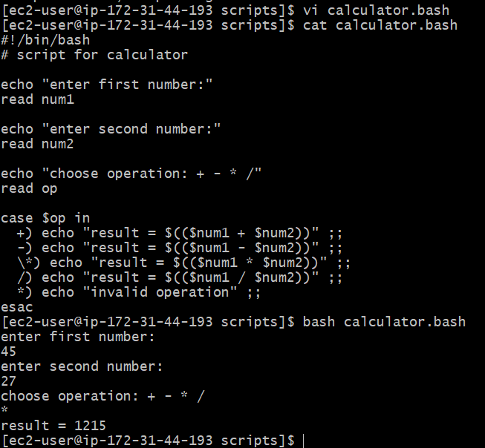
Create a bash script to check if a directory exists, if not then create a directory.
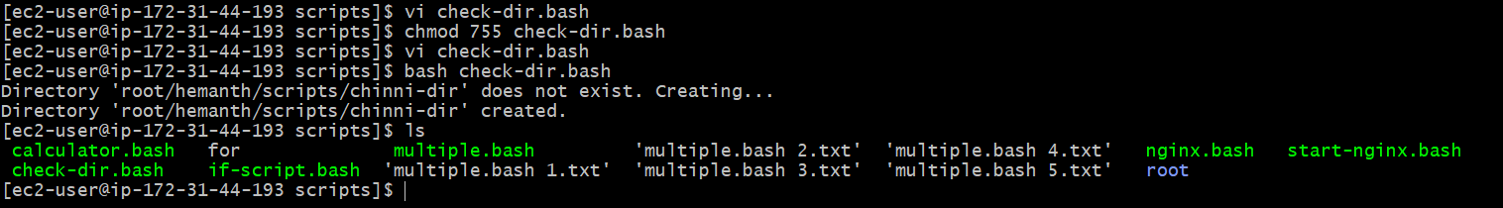
Create a bash script to delete the last 3 lines of a file..
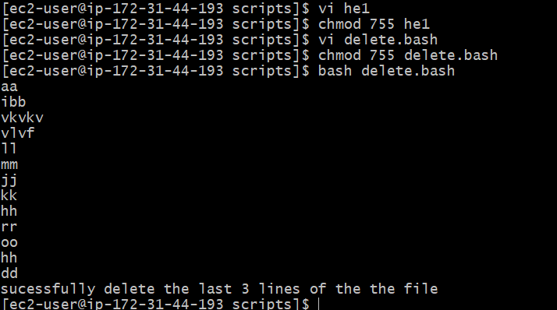
Bash script to monitor cpu and if it is more than 50% then send email notification.
first we have to install mailx service and do some configuration on /etc/mail.rc file
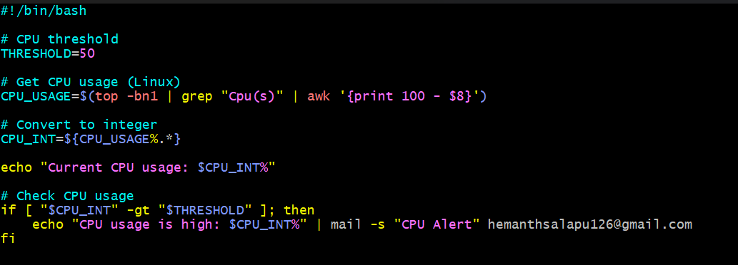
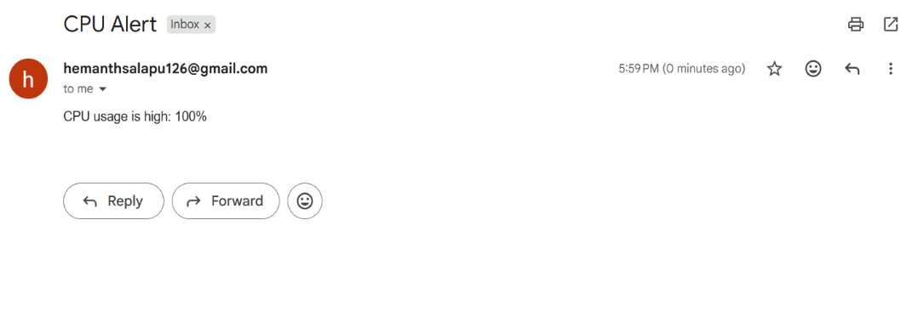

Bash script to monitor disk space and if it is more than 20% then send email notification
